H.T No
Regulations:
A20

Sreenidhi Institute of Science and Technology
(An Autonomous Institution)
Code No: 8A201 Date: 28-Mar-2023 (AN)

B.Tech I-Year II- Semester External Examination, March/April-2023 (Supplementary)
ELECTRICAL CIRCUITS AND NETWORKS-I (EEE)

Time: 3 Hours Max.Marks:70

Note: a) No additional answer sheets will be provided.
b) All sub-parts of a question must be answered at one place only, otherwise it will not be valued.
c) Missing data can be assumed suitably.
Bloom's Cognitive Levels of Learning (BCLL)

Remember | L1 | Apply | L3 | Evaluate | L5
Understand | L2 | Analyze | L4 | Create | L6

Part - A Max.Marks:20

Answer all QUESTIONS.

 |  | BCLL | CO(s) | Marks
1 | Define i) Voltage ii) Current iii) Power iv) Energy | L1 | CO1 | [2M]
2 | Mention the properties of a tree in a graph. | L1 | CO2 | [2M]
3 | Define Relative permeability and coupling coefficient? | L1 | CO3 | [2M]
4 | Convert i) 2+j5 ii) 10+j15 into polar form. | L2 | CO4 | [2M]
5 | Draw the locus diagram of series RL circuit with variable R and constant L. | L1 | CO5 | [2M]
6 | State Thevenin’s and Norton’s theorems. | L1 | CO6 | [2M]
7 | Define basic tie-set and give the condition to form basic tie-set. | L1 | CO2 | [2M]
8 | Distinguish between Self and mutual inductances. | L2 | CO3 | [2M]
9 | States the Thevenin's theorem for AC excitation with suitable diagram. | L1 | CO6 | [2M]
10 | Draw voltage current and power waveforms for pure inductive circuit? | L1 | CO4 | [2M]

Part – B Max.Marks:50
ANSWER ANY FIVE QUESTIONS. EACH QUESTION CARRIES 10 MARKS.

 |  |  | BCLL | CO(s) | Marks
11. | a) | For the bridge network shown in Figure, find the R_{ab} and i.  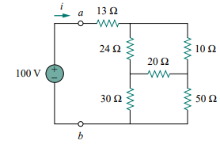 | L3 | CO1 | [5M]
 | b) | For the circuit of Figure, find the values of V₁ and V₂.  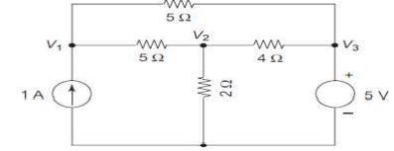 | L3 | CO1 | [5M]
12. | a) | Define Graph, Tree, Co-tree, complete incidence matrix? | L1 | CO2 | [5M]
 | b) | For the graph shown in below figure, find the complete incidence matrix.  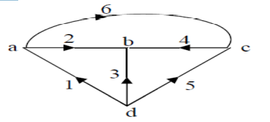 | L3 | CO2 | [5M]
13. | a) | A mild steel ring of circumference 50cm and cross-sectional area of 5cm² has a coil of 250 turns wound around it. Calculate: (i) The reluctance.  (ii) The current required to produce a flux of 700 mWb.  The relative permeability =380. | L3 | CO3 | [5M]
 | b) | Two coils connected in series-aiding fashion have a total inductance of 250 mH. When connected in a series-opposing configuration, the coils have a total inductance of 150 mH. If the inductance of one coil (L₁) is three times the other, find L₁, L₂, and M. What is the coupling coefficient? | L2 | CO3 | [5M]
14. | a) | Draw the phasor diagram representation of series RC circuit? | L1 | CO4 | [5M]
 | b) | Draw the power triangle and explain them? | L1 | CO4 | [5M]
15. | a) | Show that the locus diagram of RL circuit in parallel with variable R is a straight line. | L3 | CO5 | [5M]
 | b) | Explain the procedure to draw the locus diagram of R-L series circuit when L is varying. | L2 | CO5 | [5M]
16. | a) | Determine the equivalent circuit between the terminals A&B in the given network using Thevenin’s Theorem?  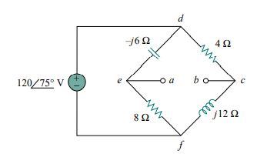 | L5 | CO6 | [5M]
 | b) | Verify superposition theorem for the circuit shown in figure below?  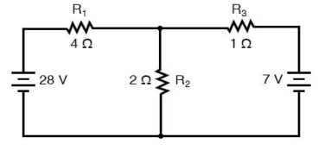 | L3 | CO6 | [5M]
17. | a) | With an example explain about Kirchhoff’s laws? | L2 | CO1 | [4M]
 | b) | Explain the concept of duality? | L2 | CO2 | [3M]
 | c) | Derive the expression for co-efficient of coupling helps in identifying how strongly two coils are coupled? | L2 | CO3 | [3M]
18. | a) | A coil has an inductance of 20mH and a resistance of 5 Ω. It is connected across a supply voltage v(t) = 100 sin 314t. Obtain a similar expression for the supply current? | L3 | CO4 | [4M]
 | b) | Show that the locus diagram of RC circuit in series with variable R is a straight line. | L3 | CO5 | [3M]
 | c) | Derive the expression for maximum average power to the load at impedance Z_{L}. | L2 | CO6 | [3M]

-- 00 -- 00 –

